Chanukah / חנוכה (Hebrew)
Hanukkah (also romanized as Chanukah or Chanuka), also known as the Festival of Lights, is an eight-day Jewish holiday commemorating the rededication of the Holy Temple (the Second Temple) in Jerusalem at the time of the Maccabean Revolt of the 2nd century BCE. Hanukkah is observed for eight nights and days, starting on the 25th day of Kislev according to the Hebrew calendar, which may occur at any time from late November to late December in the Gregorian calendar.

Hanukkah
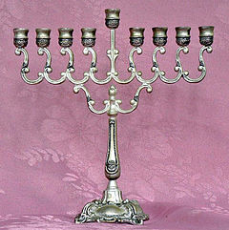
A Hanukkah menorah, or Hanukkiah
Observed by | Jews
Significance | The Maccabees successfully rebelled against Antiochus IV Epiphanes. According to the Talmud, a late text, the Temple was purified and the wicks of the menorah miraculously burned for eight days, even though there was only enough sacred oil for one day's lighting.
Celebrations | Lighting candles each night. Singing special songs. Reciting Hallel prayer. Eating foods fried in oil, such as latkes and dairy foods. Playing the dreidel game, and giving Hanukkah gelt
2015 date | Sunset, 6 December to nightfall, 14 December

