Attack on Pearl Harbor

Attack on Pearl Harbor
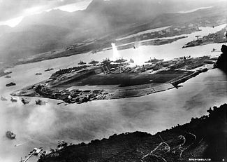
Photograph of Battleship Row taken from a Japanese plane at the beginning of the attack. The explosion in the center is a torpedo strike on the USS West Virginia. Two attacking Japanese planes can be seen: one over the USS Neosho and one over the Naval Yard.

The attack on Pearl Harbor was a surprise military strike by the Imperial Japanese Navy against the United States naval base at Pearl Harbor, in the United States Territory of Hawaii, on the morning of December 7, 1941. The attack led to the United States' entry into World War II.
The attack commenced at 7:48 a.m. Hawaiian Time. The base was attacked by 353 Japanese fighter planes, bombers, and torpedo planes in two waves, launched from six aircraft carriers. All eight U.S. Navy battleships were damaged, with four sunk. All but Arizona were later raised, and six were returned to service and went on to fight in the war. 188 U.S. aircrafts were destroyed; 2,403 Americans were killed and 1,178 others were wounded.
The attack came as a profound shock to the American people and led directly to the American entry into World War II in both the Pacific and European theaters. The following day, December 8, the United States declared war on Japan. Subsequent operations by the U.S. prompted Germany and Italy to declare war on the U.S. on December 11, which was reciprocated by the U.S. the same day.

